1. Cardinality MANY Case:  
   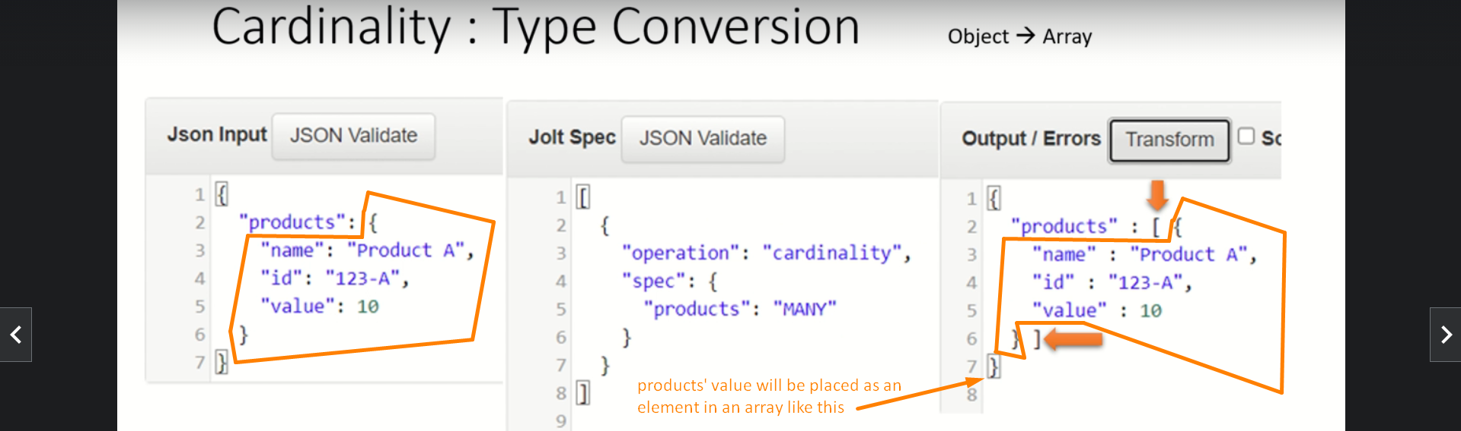
2. Cardinality ONE Case:  
   